PYTHON ASSIGNMENT 2:

BHAGAVATHY M(2019504012)

CODE:
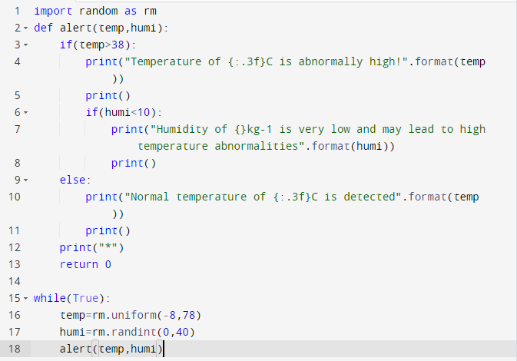

OUTPUT:
